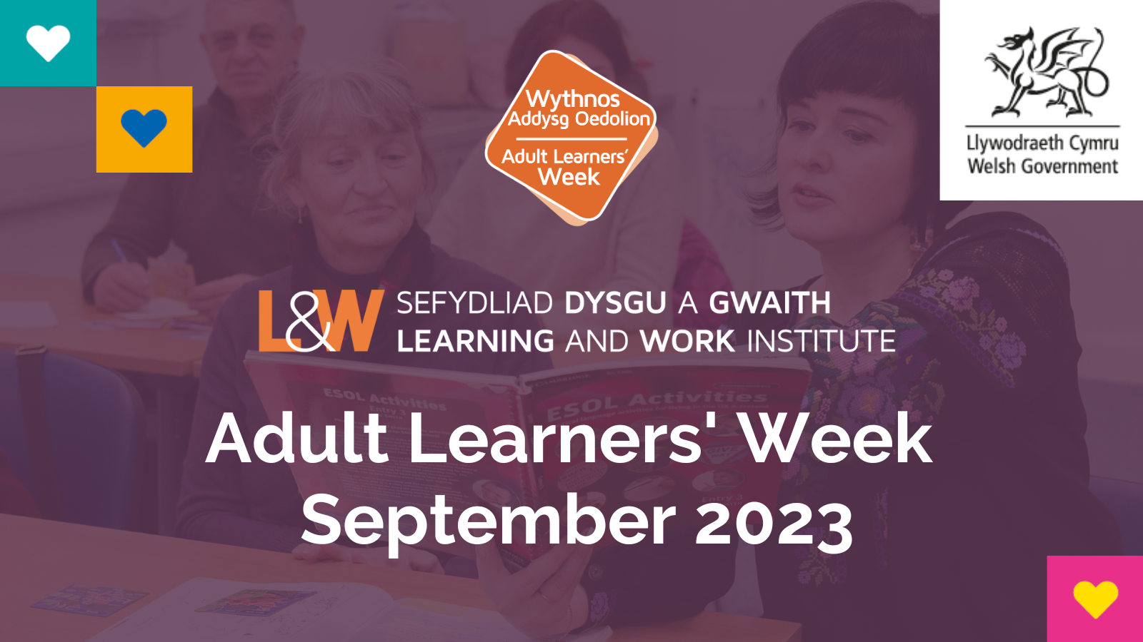

This document is also available in Welsh.

Your invitation to join Adult Learners’ Week from 18 – 24th September, with promotion taking place throughout the month.

Adult Learners’ Week plays a major role in promoting opportunities for individuals, families, and communities to learn new skills, to support health and wellbeing, begin new hobbies or to seek new opportunities to retrain and make a fresh start.

We want Adult Learners’ Week to make a difference to people’s lives and be a catalyst for many to take a step back into learning, to find out more about opportunities available to them, to seek advice and guidance, and to be inspired to upskill. We want to see better signposting and opportunities that will inspire people to improve their confidence and wellbeing, to flourish in their careers, and develop a love for lifelong learning.

Jeremy Miles, Minister for Education and the Welsh Language has firm commitments set out towards creating Wales as a “second chance” nation.
“When it comes to education, our lives should not – must not – depend on one shot, one chance, one pathway, one decision. It must never be too late to learn. Or to become more democratically and critically engaged through education. To learn that new skill, acquire that new qualification. To become more personally, culturally and academically fulfilled.
I want Wales to be a nation of second chances in education.”
We want to work with a range of organisations to promote learning opportunities for adults and families – both formal and informal, throughout September and as part of our focus
Week.

The Adult Learners’ Week platform has been developed to host information, courses, and special events to connect people to partners and stakeholders across Wales and beyond.

Last year, we hosted over 500 listings from a wide range of organisations including The Open University in Wales, UNISON, Cardiff Metropolitan University, Adult Community Learning providers, Coleg Menai, Wales Council for Deaf People, OASIS, RNIB Cymru, Wales TUC and others.

Working in partnership with the Welsh Government, we successfully launched the platform as part of a multi-media campaign to promote adult learning at the height of the coronavirus pandemic.

As we recover from the pandemic, we need your support to make lifelong learning more accessible. Watch this video to find out more about Adult Learners’ Week.

This year, as part of the campaign we are planning for a mix of online, live and in-person events and courses, taster sessions, open days, and outreach events, that will be promoted to people across Wales throughout September, as well as the focus week 18th – 24th September.

Use the Adult Learners’ Week platform to promote your courses, open events, online tasters and learning resources to help engage and inspire people to learn something new in way that suits them.

Learning and Work Institute is continuing its partnership with the Welsh Government to build a network of campaign partners and to support this year’s multi-media campaign with awareness raising, promotion and advertising across press, radio, social and digital media. Click here to see the events already accessible on the platform.

Why should I take part?

- It’s an opportunity to engage with new and existing audiences.
- You’ll be part of a major partnership in Wales that aims to promote lifelong learning.
- A profile on the Adult Learners’ Week platform, will bring more awareness of your provision.
- You’ll be playing a key role in connecting people in Wales to get support with health & wellbeing, learning and employment opportunities.
- You’ll be part of a Wales-wide campaign to share positive, aspirational stories to inspire others to consider learning, developing new skills and make a fresh start.
What you’ll need to provide

We’re looking for high quality free digital / in-person resources, courses and taster sessions that will help adults learn a new skill. If these are available/delivered in both English and Welsh, that’s even better.

Content could include:
- One-off / taster courses
- Introductory courses
- Taster sessions
- Work sheets
- Ongoing courses
- Open days
- Community events
- Webinars
- Conferences
- Links to careers advice and information

Next Steps

You may already be a campaign partner or have worked with us previously

You can access your Provider Profile on the platform by logging into your account – this will allow you to update your provider information and upload your learning content.
- Check you are registered on the platform https://adultlearnersweek.wales/en/providers/
- If you have your log in details then please log in to your account https://adultlearnersweek.wales/en/my-account/ to start adding your course/event/resources listings onto the platform (all content must be uploaded in English and Welsh, even if the activity itself is not delivered in bilingually)
- If you cannot remember or locate your login or have any queries with your account, please email alwevents@learningandwork.org.uk or call 07920 040653 to ask for assistance.

You can save your information at any time and come back to the page before publishing. You can upload and edit your content any time before and during Adult Learners’ Week, however we highly recommend that all content is uploaded by 29th August to ensure your content is considered within the marketing communications.

And if you are new to the campaign – it’s great to have you on board!

- To create a Provider Profile, its quick and easy and the benefits are endless. Please complete the short form below and send back to: alwevents@learningandwork.org.uk or call 07920 040653 if you need any assistance.

Name
Organisation / business name and type
What does your organisation do – a brief overview
Email address
Contact number
Web address
Brief description of activity (course/event/taster etc.)
Max 250 words
Credentials/ qualifications – please outline qualifications or experience of the tutor/ organisation

- A member of the Learning and Work Institute team will review your form and set up your account. Once complete they will provide you with all the information you need so you can update your provider profile
- Please log in to your account (https://adultlearnersweek.wales/en/my-account/) and start adding your course/event/resources listings onto the platform bilingually.

You can save your information at any time and come back to the page before publishing. You can upload and edit your content any time before and during Adult Learners’ Week, however we highly recommend that all content is uploaded by 29th August 2023 to ensure your content is considered within the marketing communications.

I’ve uploaded my content, what now?

Please keep your eyes peeled for more information, updates and marketing resources coming to you within the next few weeks and in the lead up to Adult Learners’ Week. In the meantime, let your social following and networks know that you are taking part and encourage them to do the same! We will also circulate an evaluation for completion after your events take place, your feedback will help us to evaluate the impact of the campaign.

#neverstoplearning
Working Wales

We look forward to working with you.
Learning and Work Institute Wales

Website: www.learningandwork.wales
Twitter: @LearnWorkCymru
LinkedIn: Learning and Work Institute
Facebook: @learningandworkinstitute

