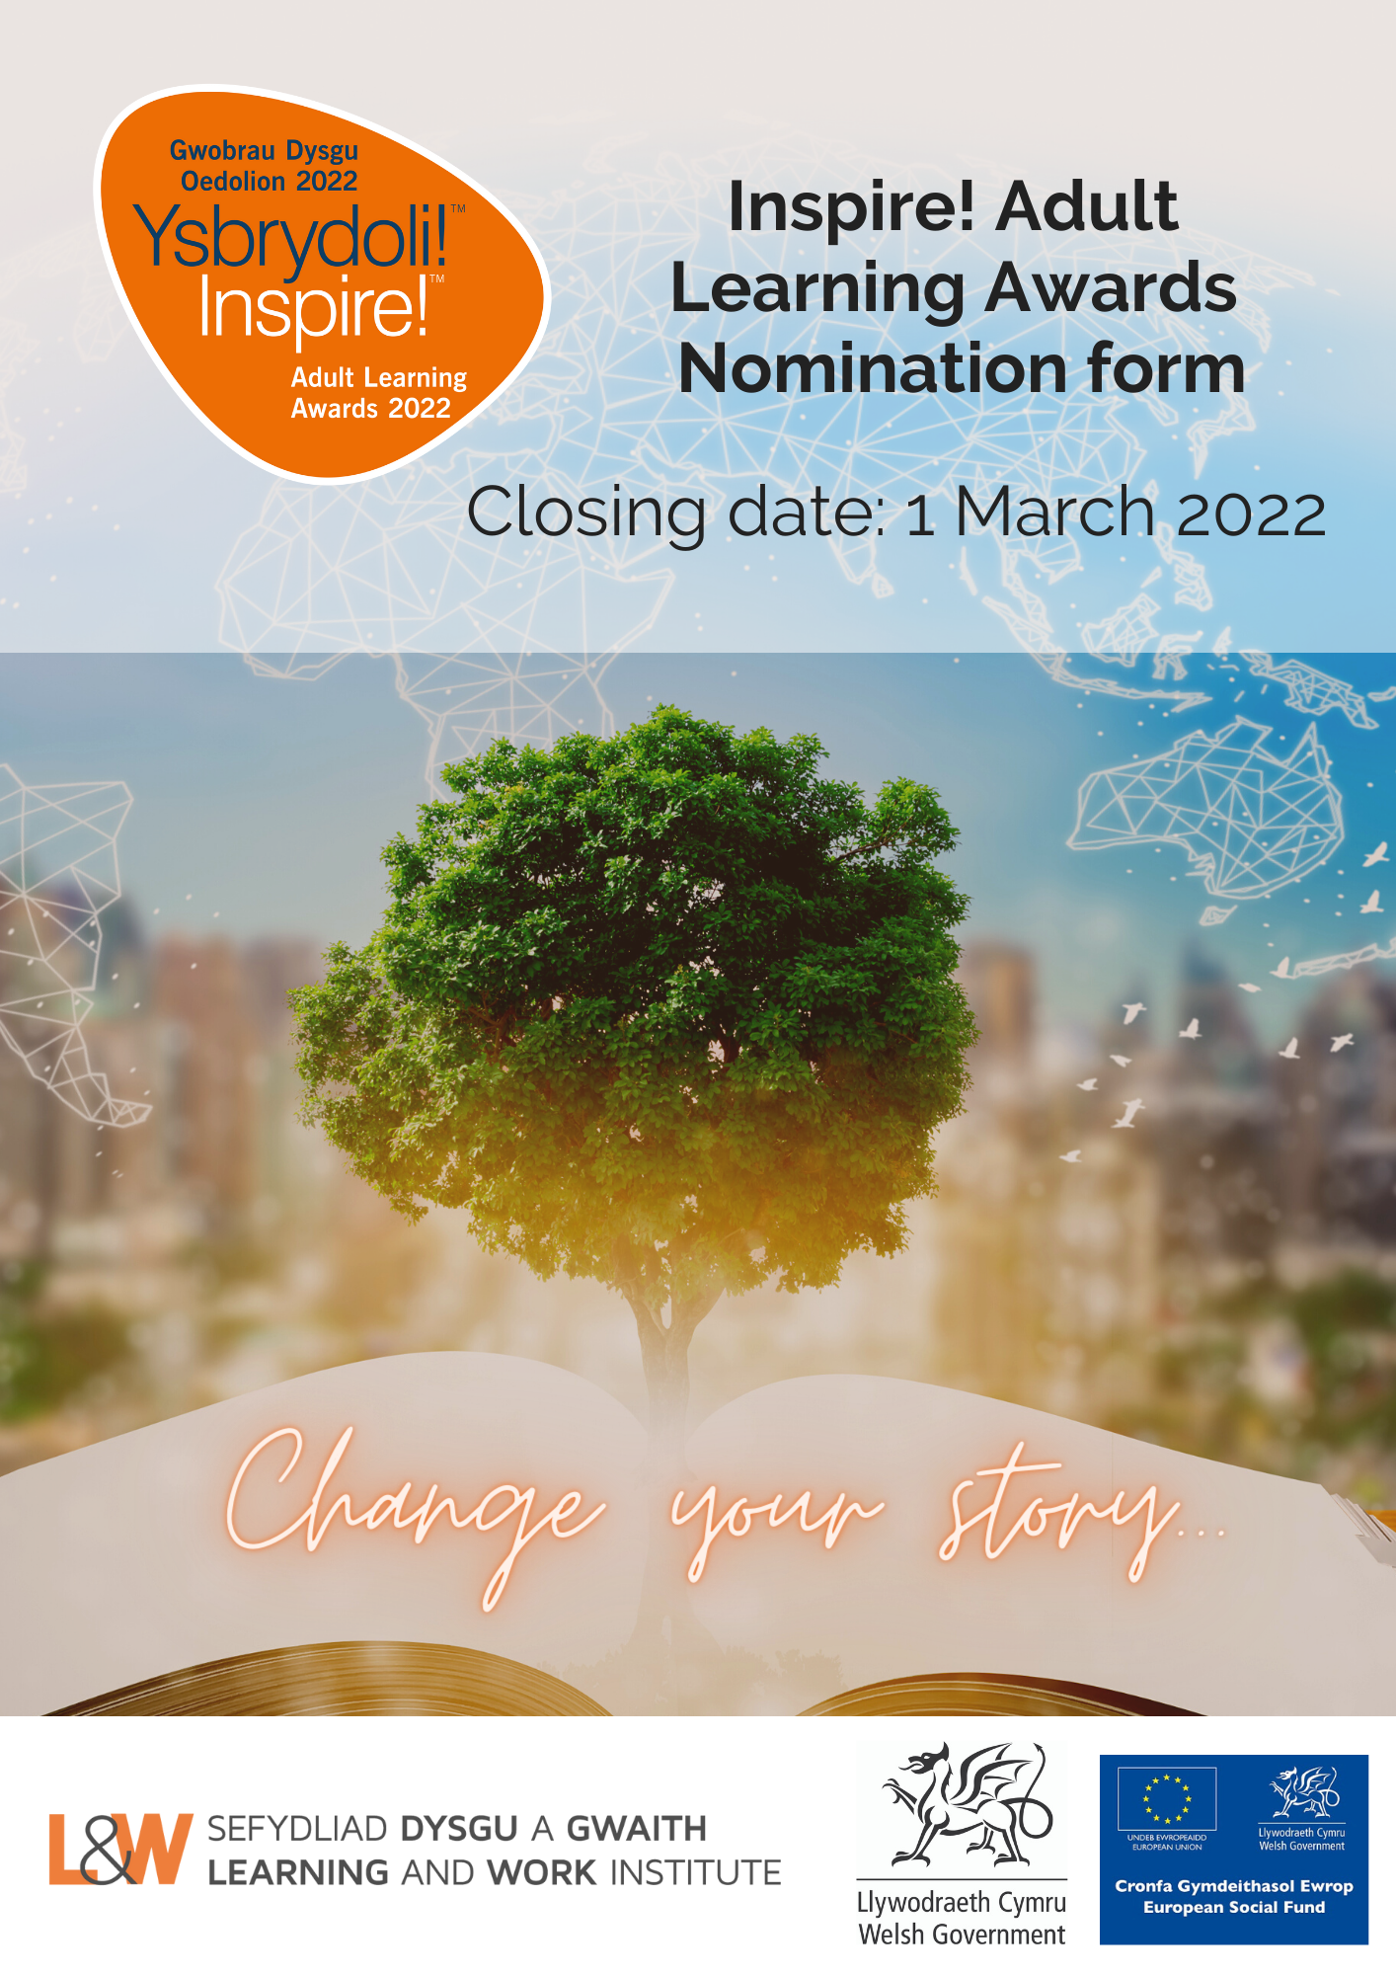
This document is available in Welsh.

SECTION 1
NOMINATOR DETAILS

1. Please enter your contact details:
First and last name
Organisation
Postal Address
Email
Daytime phone number
Mobile phone number
NOMINEE DETAILS
2. Are you nominating (please tick as appropriate):
An individual (go to question 3)

A project / organisation (go to question 5)
3. Please indicate your relationship to the person you are nominating

4. Please enter the contact details of the individual you are nominating.
Name (first and last name)
Note: this is the name that will appear on the certificate, please double check the spelling.
Organisation – if applicable
Region / County
Postal Address
Email
Daytime phone number
Mobile phone number
The name of the learning provider - where the person is learning

5. Please enter the contact details for the project or organisation you are nominating.
Project / Organisation name
Note: this is the name that will appear on the certificate, please double check the spelling.
Contact name
Office Postal Address
Postal Address
Email
Daytime phone number
Mobile number

AWARD CATEGORIES
6. Please indicate the category you would like the nominee to be considered for.
You can find a description of award categories in this Guidance document.
Award Categories | Please tick one box only
Skills for Work
Young Adult Learner
Life Change & Progression
Ageing Well
Starting out – Welsh Beginner
Different Past: Shared Futures
Essential Skills for Life
Active Wales
Wales for Future Generations
Hywel Francis Award for Community Impact
Workplace Change Makers

SECTION 2
NOMINATOR STATEMENT
Please use this section to tell us about the individual, project or organisation you are nominating. In writing your statements, please refer to the Inspire! Awards 2022 category guidance and our guidance on How to submit a successful nomination, as judges will use these when making their decisions.
Alternatively, if you would like to submit your nomination statements via video clip, you will still need to complete Sections 1 and 3 of this nomination form and return it with your film. Films should be no longer than 3 minutes.
Please click here for guidance on how to capture and submit your video.
If you’d like to submit any further supporting statements or images, please submit them when you send in your completed nomination form.
Refer to the category you are nominating for and write your nomination in relation to this.
If you are nominating an individual, you may wish to include:
- How learning has moved the nominee forward in life and what they intend to do in the future
- Details of the learning completed, progress made and any personal and professional achievement
- What is transformational about their learning journey and what has changed as a result
- Describe how learning has had a positive impact on the individual’s life, and on those around them – how have they developed and used their skills in their family, workplace, or community
If you are nominating a project you may wish to include:
- Project objectives, details of the learning completed, progress made and any achievements
- Any innovative approaches to learning
- What is transformational about the project and what has changed as a result
- Explain how learning has had a positive impact on those involved, in the community or on those around them
- Impact and outcomes of the project or activity and any future plans for further development.
If you are nominating an organisation you may wish to include:
- The approach to workforce development – who is being targeted, how are they being reached
- The learning, skills, training, and development opportunities available to employees and the progression of the learners involved
- The contribution the learning has made to the organisation, including to the working environment and to staff (please provide any evidence)
- The partnership involved in delivering the learning activities
- Any particular response to the coronavirus pandemic for example by supporting people and communities to switch to online/blended learning

7. Please limit your statement to 500 words. If you would like to submit additional information or photos, send them together by email when you submit in your completed form).

NOMINEE STATEMENT
If your nomination is for a project or organisation, you can use this section to collect statements from the people/partners or other stakeholders involved.
If you are nominating for an individual award this section is for your nominee to complete. This is your opportunity to tell us about your learning experiences and how it has changed your life. Information supplied will benefit your nomination. Tell us what learning you have completed; are there any barriers you have had to overcome to get where you are now? What messages do you have to inspire others to return to learning and where do you think your journey will take you next?
8. Please limit your statement to 500 words. If you would like to submit additional information, photos, please submit them by email when you send in your completed form.

SECTION 3
PRIVATE INFORMATION AND PUBLICTY
What happens if your nomination is shortlisted
Once nominations have been submitted, a panel of judges will go through the shortlisting process to select nominees in each category to go forward to an independent panel of judges. Please note that if your nomination is selected at the shortlisting stage - we may come back to you for further information.
What happens if your nomination is selected as an award winner
The Inspire! Awards raise the profile of opportunities for lifelong learning. If your nomination is selected as a winner, we will want to share your story in press and media activities.
PR activity will include:
- Press release stories to be published through social and digital media.
- A film and photography shots to promote award winners.
- Media coverage and interviews for award winners and possibly those who are shortlisted and selected as a case study
- Nominators may be included in the film or photography
We will always ask your permission before featuring your nominee’s story in any of our press or media activities.
9. If there are details in your nomination which you do not wish to be made public, please let us know in the box below. Please also indicate if you or any of those involved in this nomination do not wish to have photographs taken or be included in film and PR.

PRESS, PR, MARKETING AND CONTACT DETAILS
Inspire! Award winners often generate local and national press or media interest. If your nominee is selected for an Inspire! award, Learning and Work Institute would like to liaise with your PR or Marketing Manager.
10. Please enter the details of your PR/Marketing manager
Organisation Name
Contact Name
Email address
Daytime phone number
Mobile phone number
Organisation’s Twitter handle | @
Organisation’s Facebook | @
Organisation’s Instagram Page | @
NOMINEE AND NOMINATOR DECLARATION
Please read the following statements carefully before agreeing to and ticking each of the declarations. Only applications signed by both nominator and nominee will be accepted.
Nominator’s Declaration
By submitting this form and ticking the box, I confirm that:
- I wish the named person, project, or organisation to be nominated for an Inspire! Award 2022
- The information supplied in this form is correct to the best of my knowledge and that the statement is true and accurate
- I give my consent for Learning and Work Institute to use the information in this form
- I understand that if the named person is selected as a winner, I may be asked to take part in press and media activities
- I have read this form and declaration carefully and fully understand its meaning

Nominee’s Declaration
By submitting this form and ticking the box, I / we confirm that:
- I / We wish to be nominated for an Inspire! Award 2022
- The information supplied in this form is correct to the best of my / our knowledge and the statement is true and accurate
- I / We understand if I am / we are selected as a winner, I/we will be asked to take part in press or media activities, this includes having my / our picture taken, taking part in a film, and having my / our story included in Inspire! Awards materials such as a press release, social and digital media for inspire! Award promotional materials – and I will be asked to sign a GDPR consent for these.
- I understand that if my circumstances change and I can no longer take part in any press and media, I will alert L&W at my earliest convenience
- I / We have read this form and declaration carefully and fully understand its meaning

11. We would like to keep you informed by email about further Learning and Work Institute events, activities, future award nominations and our campaigning work in Wales. If you are happy for us to contact you, please tick the box below.
Yes

If you would like to update your preferences, please contact:
enquiries@learningandwork.org.uk
Learning and Work Institute will only use personal data in accordance with the terms of consent given by the individual or group.

DATA PROTECTION STATEMENT
The Learning and Work Institute is registered under the Data Protection Act 1998 (Registered Number Z7412510). Personal information supplied to the Learning and Work Institute will be stored securely and may be used in relation to the Learning and Work Institute’s work.
Full details of the purposes for which the Learning and Work Institute processes personal information is in our Data Protection Register entry, which can be found on the Information Commissioner’s website www.ico.org.uk . At no time will we share personal information with other organisations without your express consent.

How can I submit my nomination form?
Please email your completed form to:
inspire@learningandwork.org.uk
Alternatively, you may also send it by post to:
Learning and Work Institute, S4C Media Centre, Parc Ty Glas, Llanishen, Cardiff, CF14 5DU

The closing date for entries is Tuesday 1 March 2022

